Crackathon Engineering

Case Study

By J&J:



**Johnson & Johnson**:

At Johnson & Johnson, we blend our heart, science, and ingenuity to profoundly change the trajectory of health for humanity. Johnson & Johnson Medical supports this vision by providing solutions to healthcare challenges faced by doctors, patients, and nurses. We have a long tradition of developing products that advance surgeons’ work and improve patients’ lives with focus on pioneering solutions to deliver better health.

**Our Credo**

Johnson & Johnson is guided by the values set forth in Our Credo, created by General Robert Wood Johnson in 1943. These principles have guided us over the years and continue to set the tone of integrity for the entire Company. At all levels, the employees of Johnson & Johnson are committed to the ethical principles embodied in Our Credo and these principles have been woven into the fabric of the Company. We believe it’s a recipe for business success. Put simply, Our Credo challenges us to put the needs and well-being of the people we serve first.

**Project Title:**

**Vertical Start-up of High-Speed Automated Blister machine**

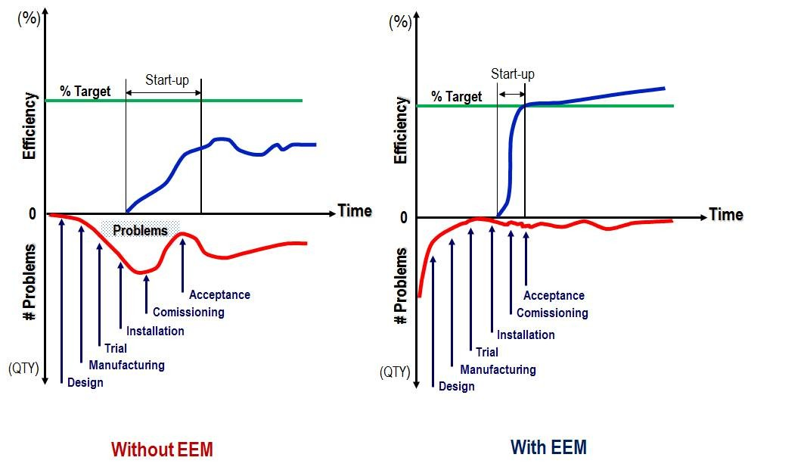

**Normal Start up after Installation Vertical Start up after Installation**

**Background of the Project:**

Ethicon India (part of J&J Medical) has been manufacturing sutures in India for over 30 years at its dedicated site located in Aurangabad, Maharashtra. It represents the largest local suture manufacturing site in the country with in-house Ethylene oxide facility.

To improve the performance of site , Equipment with latest Technology is being installed.

Vertical Start up is a major opportunity for Improvement considering the learnings from recently installed equipment.

For your case study, you need to work on a Vertical Start-up of High-Speed Automated Blister machine which is being installed at J&J Aurangabad factory. Once in operation, it will be one of the critical assets for the site which shall have major contribution to achieve the site target.

Following are the machine details that you can consider building your case.

|  |  |
| --- | --- |
| **OEM** | Blister Master |
| **Equipment Speed** | 100 packs /min |
| **Material Infeed** | Automated (Robotic pick & place) |
| **Material Outfeed and Load in Tray** | Automated collation to next unit operation |
| **Printer** | Inbuilt printer for online printing of product details |
| **Vision System** | Advanced vision for defects detection & rejection |
| **No. of operators required** | 2 |
| **Material** | * Semi-permeable paper, * Aluminum foil, * Peelable paper (for product information printed by printer), * Suture Product (ABC) |
| **HMI Provision** | Inbuilt |
| **PLC Provision with LAN connectivity** | Inbuilt |
| **Service Support** | Vendor is out of India; however, local support is available |
| **Utility Requirements** | * Electricity * Compressed Air * Chilled Water * Vacuum |
| **Spares lead time** | 3 months |
| **Machine Dimensions** | E2E Length: 18 meters  Width: 2.5 meters  Height: 2.4 meters |

Machine picture for reference only-

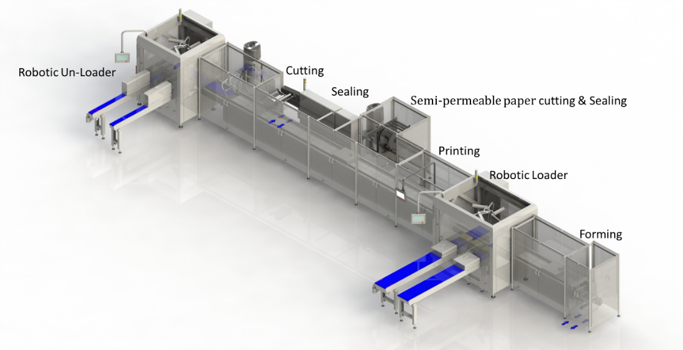

**Project Objective & Deliverables:**

1. Propose a Vertical start-up plan to achieve ≥80% efficiency (i.e., OEE) post-handover of machine for production within 1 month.
2. Identify the industry benchmark practices for Vertical start-up of newly installed equipment.
3. Frame a governance model to track the vertical startup of the equipment.
4. Enlist the major contributing factors that can impact the performance of the machine.
5. Propose a solution to effectively maintain spares for critical parts of equipment (Proposed solution should also consider high lead time and inventory carrying cost).
6. Propose a sustainability model to maintain and further improve the efficiency above 80%.

Guide Name: Ketan Diwan

Mentor Name: Kiran Edke, Santosh Kulkarni

Johnson & Johnson India: <http://www.jnjindia.com/>

OUR CREDO: <http://www.jnj.com/connect/about-jnj/jnj-credo/>

Crackathon Engineering

Case Study

Submitted:

**J&J Case Study**

The vertical startup of a new machine is a complex and challenging process. It requires the coordination and cooperation of a wide range of stakeholders, including engineers, operators, quality assurance personnel, supply chain managers, and financial analysts.

The governance model for tracking the vertical startup of a new machine is a framework that helps to ensure that all of these stakeholders are aligned on the goals and objectives of the process, and that the process is completed on time and within budget.

The governance model consists of the following components:

* Steering Committee: The steering committee is the highest-level body responsible for overseeing the vertical startup process. The committee is composed of representatives from all of the key stakeholders, and is responsible for setting the overall direction of the process, ensuring that the process is aligned with the overall business goals of the organization, and resolving any major issues that may arise during the process.
* Technical Team: The technical team is responsible for conducting the required testing and verification procedures. The team is composed of engineers and technicians with expertise in the operation and maintenance of the new machine. The technical team ensures that the machine is operating properly and that it meets all of the specifications. The technical team also develops and implements the machine's operating procedures.
* Quality Assurance Team: The quality assurance team is responsible for ensuring that the machine produces high-quality products. The team is composed of quality engineers and technicians with expertise in the inspection and testing of products. The quality assurance team conducts inspections and tests throughout the vertical startup process to ensure that the machine is meeting all quality standards. The quality assurance team also develops and implements the machine's quality control procedures.
* Communication Plan: A communication plan is essential for keeping all stakeholders informed of the vertical startup progress. The plan should include regular status updates, meetings, and training sessions. The communication plan should also be used to communicate any risks or issues that may arise during the vertical startup process. The communication plan should be developed in collaboration with all stakeholders, and should be clear, concise, and easy to understand.
* Risk Management Plan: A risk management plan is essential for identifying and mitigating any potential risks to the vertical startup process. The plan should include a list of risks, their likelihood, and impact, as well as a plan for mitigating each risk. The risk management plan should be developed in collaboration with all stakeholders, and should be regularly reviewed and updated as needed.
* Success Metrics: Success metrics will help to ensure that the machine is meeting all expectations. The metrics should include uptime, throughput, quality, and cost. Uptime is the percentage of time that the machine is operating properly. Throughput is the number of products that the machine can produce in a given period of time. Quality is the percentage of products that meet all quality standards. Cost is the total cost of operating the machine. The success metrics should be developed in collaboration with all stakeholders, and should be clear, concise, and easy to measure. The success metrics should also be regularly reviewed and updated as needed.

The governance model for tracking the vertical startup of a new machine is a critical tool for ensuring the success of the process. By following the model, all stakeholders will be aligned on the goals and objectives, risks will be mitigated, and success will be achieved.

Here are some additional details about each of the components of the governance model:

* Steering Committee: The steering committee should be composed of representatives from all of the key stakeholders, including engineering, operations, quality assurance, supply chain, and finance. The steering committee should meet regularly to review the progress of the vertical startup process, and to make any necessary decisions or adjustments.
* Technical Team: The technical team should be composed of engineers and technicians with expertise in the operation and maintenance of the new machine. The technical team will be responsible for conducting the required testing and verification procedures, and for developing and implementing the machine's operating procedures.
* Quality Assurance Team: The quality assurance team should be composed of quality engineers and technicians with expertise in the inspection and testing of products. The quality assurance team will be responsible for conducting inspections and tests throughout the vertical startup process, to ensure that the machine is meeting all quality standards.
* Communication Plan: The communication plan should include regular status updates, meetings, and training sessions. The communication plan should also be used to communicate any risks or issues that may arise during the vertical startup process. The communication plan should be developed in collaboration with all stakeholders, and should be clear, concise, and easy to understand.
* Risk Management Plan: The risk management plan should include a list of risks, their likelihood, and impact, as well as a plan for mitigating each risk. The risk management plan should be developed in collaboration with all stakeholders, and should be regularly reviewed and updated as needed.
* Success Metrics: The success metrics should include uptime